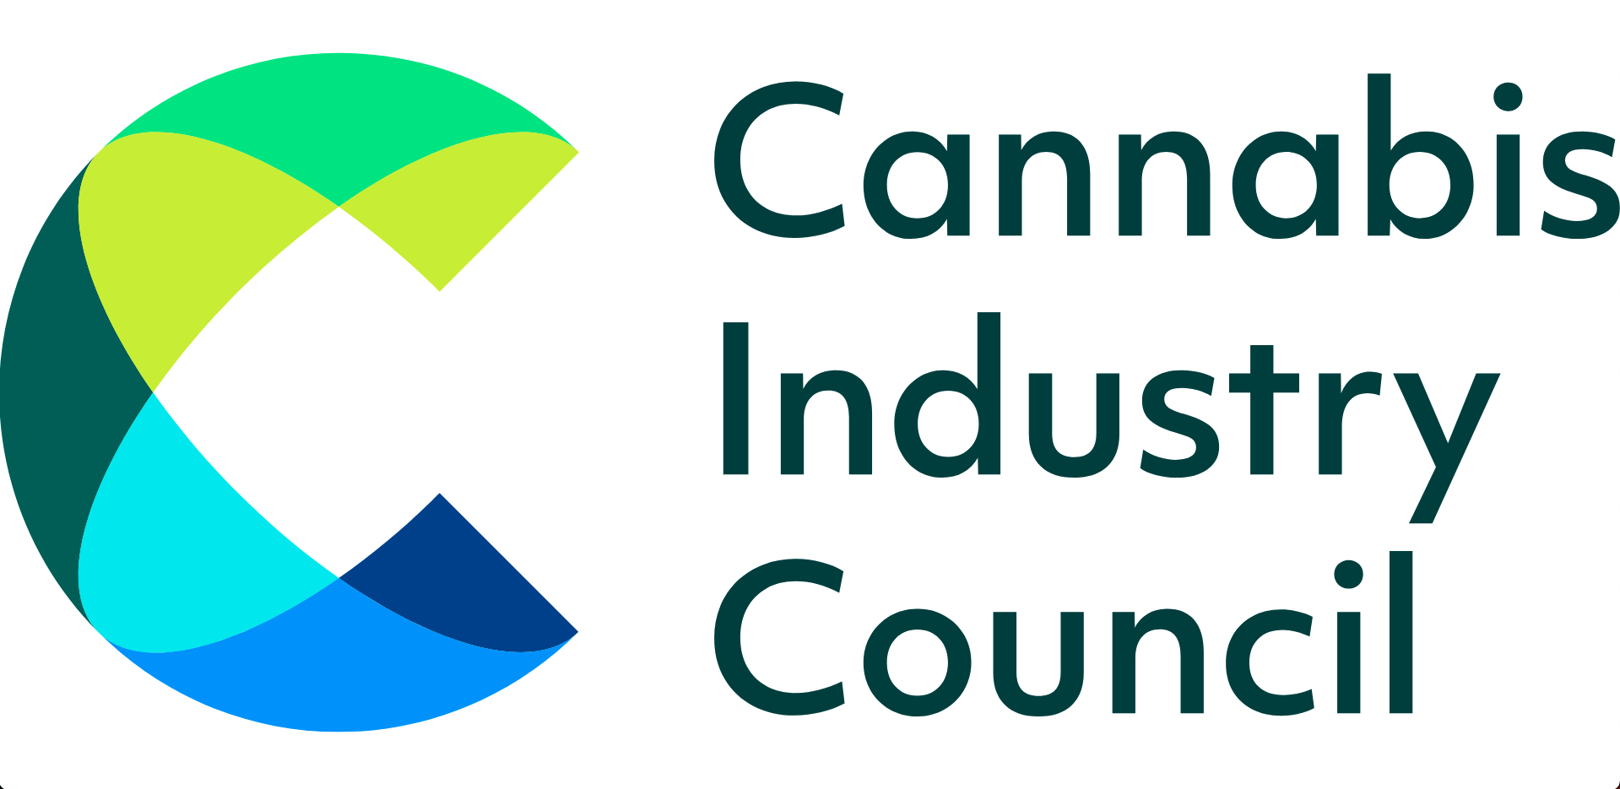

Please sign EDM 1410 - GPs prescribing cannabis medicines

Dear XXXX MP,

We are writing to you today in support of over 1.8 million patients in the UK who are suffering.

In late 2018, then Home Secretary Sajid Javid MP introduced new rules which enabled specialist medical practitioners - but not GPs - to be able to prescribe cannabis medicines to patients.

This has resulted in around 1,000 patients annually receiving cannabis prescriptions on the NHS, and circa 20,000 patients each year obtaining private prescriptions.

However, according to YouGov research, there are 1.8 million people in the UK accessing the illicit cannabis market for medical reasons.

This is partly due to GPs not being able to prescribe medical cannabis, and because those on low incomes or disability benefits struggle to afford private cannabis prescriptions.

We are calling for GPs to be allowed to prescribe cannabis medicines to their patients. Please sign this EDM in support - https://edm.parliament.uk/early-day-motion/61146

For more information please contact Mike Morgan-Giles, CEO of the Cannabis Industry Council - mikemg@cicouncil.org.uk

Kind regards,

YYYY

